# 

Asian Institute of Technology

School of Engineering and Technology

Department of ICT

Computer Science and Information Management

Data Science and AI Program

[AT 82 - DSAI] Business Intelligence and Analytics (BI&A)

Assignment 2

by

Kyi Thin Nu (st124087)

Assignment 2

Multi Criteria Decision Making

# Analytic Hierarchy Process

## Step 1: Define the problem and Criteria

### 1.1 Define the problem

Scenario3: Selecting the best employee to be promoted

### 1.2 Criteria Identification:

* Performance:
  + *Sub-criteria*:
    - Achievement of targets
    - Quality of work
    - Leadership skills
* Experience and Tenure:
  + *Sub-criteria*:
    - Years of experience in the company
    - Previous roles and responsibilities
    - Specialized skills acquired over time
* Skills and Competencies:
  + *Sub-criteria*:
    - Technical skills relevant to the job
    - Soft skills like communication, teamwork, problem-solving
    - Adaptability and learning agility
* Potential for Growth:
  + *Sub-criteria*:
    - Willingness to take on new challenges
    - Capacity for leadership roles in the future
    - Ability to innovate and drive change

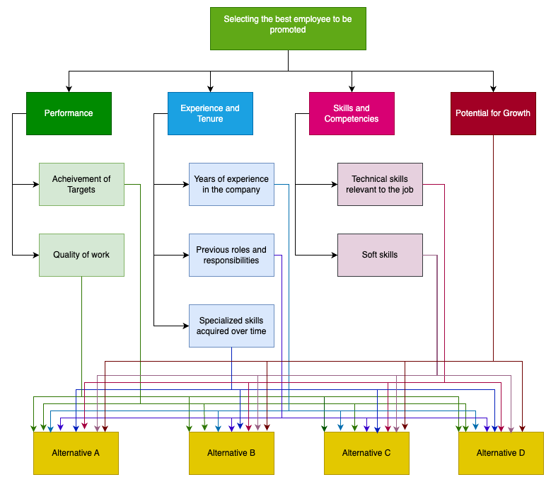

## Step 2: Define Alternatives

### 2.1 Define Alternatives

I have 4 alternatives to select the best employee to be promoted: employee A, employee B, employee C, employee D for the position.

### 2.2 Define Characteristics of the grading of each criteria

| Grade | 1-2 | 3-4 | 5 | 6-7 | 8-9 |
| --- | --- | --- | --- | --- | --- |
|  | Performance | | | | |
| Achievement of Targets | Fails to meet targets regularly | Rarely meets targets | Occasionally meets targets | Meets targets consistently | Exceeds targets consistently |
| Quality of Works | Poor quality work with significant errors | Below-average quality with noticeable errors | Satisfactory quality but requires improvement in some areas | High-quality work with occasional minor errors | Exceptional quality with minimal errors |
|  | Experiments and Tenure | | | | |
| Years of Experiences | Less than 1 year of experience | 1-3 years of experience | 4-6 years of experience | 7-9 years of experience | 10+ years of experience |
| Previous roles and responsibilities | Inexperienced or poorly performed in previous roles | Limited experience in previous roles, struggled with responsibilities | Satisfactory performance in previous roles but limited leadership experience | Consistently performed well in previous roles with increasing responsibilities | Held significant leadership roles with notable responsibilities |
| Specialized skills | Lacks any relevant specialized skills for the job | Limited specialized skills, requires significant improvement | Adequate level of specialized skills but lacks depth or variety | Proficient in several specialized skills relevant to the job | Mastered multiple specialized skills relevant to the job |
|  | Skills and Competencies | | | | |
| Technical skills relevant to the job | Lacks essential technical skills required for the job | Limited technical skills, requires significant training or development | Adequate level of technical skills but may require training or improvement in some areas | Proficient in most technical skills required for the job | Highly proficient in all technical skills required for the job |
| Soft Skills | Poor soft skills, significant improvement needed in communication, teamwork, and problem-solving | Below-average soft skills, struggles with communication, teamwork, or problem-solving | Demonstrates satisfactory soft skills but may need improvement in some areas | Strong communication, teamwork, and problem-solving skills | Exceptional communication, teamwork, and problem-solving abilities |
|  | Potential for Growth | | | | |
| Potential for Growth | Resistant to taking on new challenges, avoids new responsibilities | Hesitant to take on new challenges, requires persuasion or motivation | Open to new challenges but may need encouragement or guidance | Willing to take on new challenges when presented, shows initiative | Eager and proactive in seeking out new challenges and opportunities |

### 2.3 Define Employee Characteristic Table

|  | Employee A | Employee B | Employee C | Employee D |
| --- | --- | --- | --- | --- |
|  | Performance | | | |
| Achievement of Targets | 9 | 7 | 5 | 5 |
| Quality of Works | 7 | 7 | 5 | 5 |
|  | Experiments and Tenure | | | |
| Years of Experiences | 9 | 8 | 5 | 1 |
| Previous roles and responsibilities | 7 | 6 | 4 | 3 |
| Specialized skills | 8 | 9 | 4 | 2 |
|  | Skills and Competencies | | | |
| Technical skills relevant to the job | 5 | 7 | 5 | 5 |
| Soft Skills | 7 | 9 | 7 | 7 |
|  | Potential for Growth | | | |
| Potential for Growth | 7 | 8 | 6 | 4 |

## Step 3: Establish priority amongst criteria and alternatives using pairwise comparison.

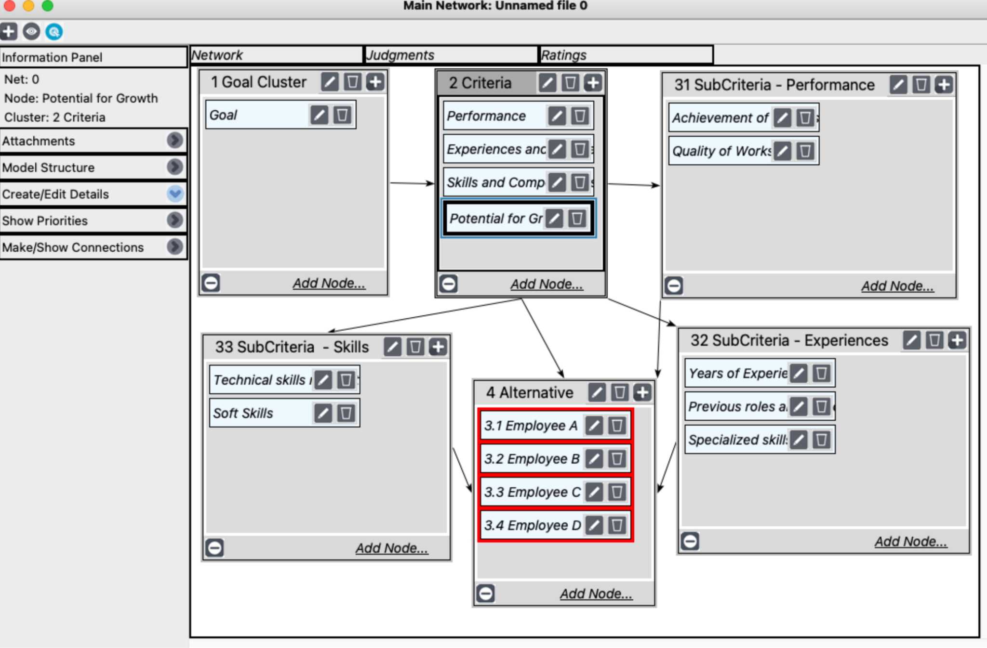

## Step 4: Check consistency amongst the pairwise comparison.

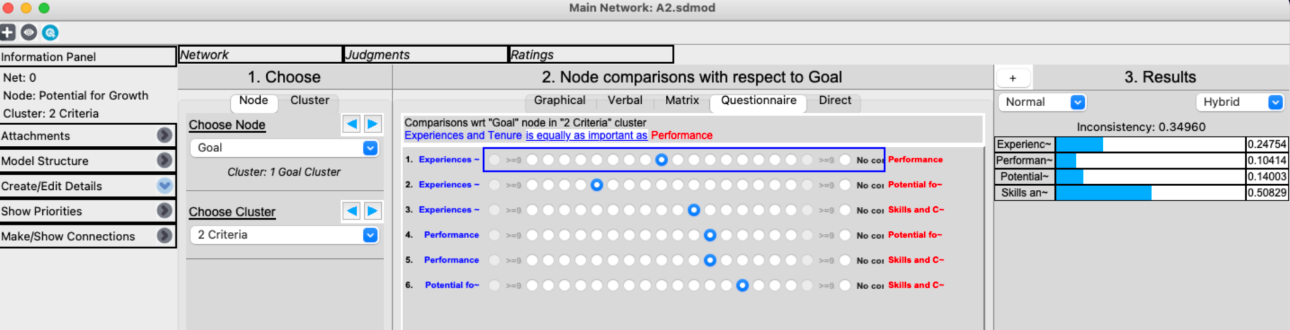

## Step 5: Evaluate relative weights from the pairwise comparisons and get the calculated overall priorities for the alternatives.

### Achievement of Targets

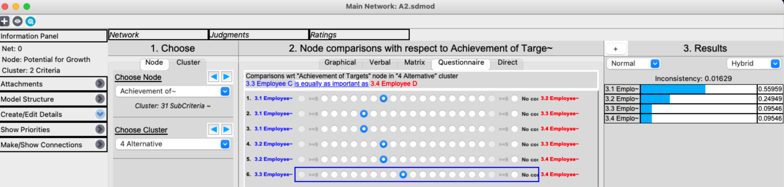

### Quality of works

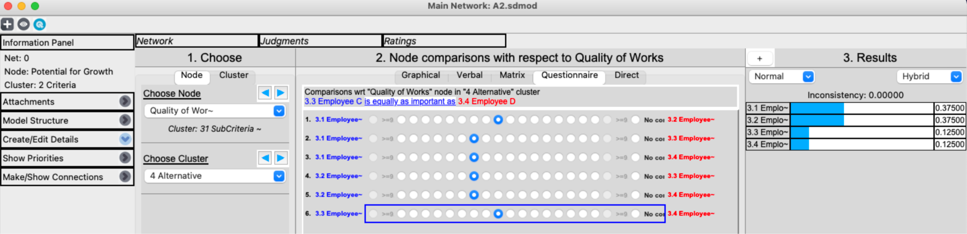

### Years of Experiences

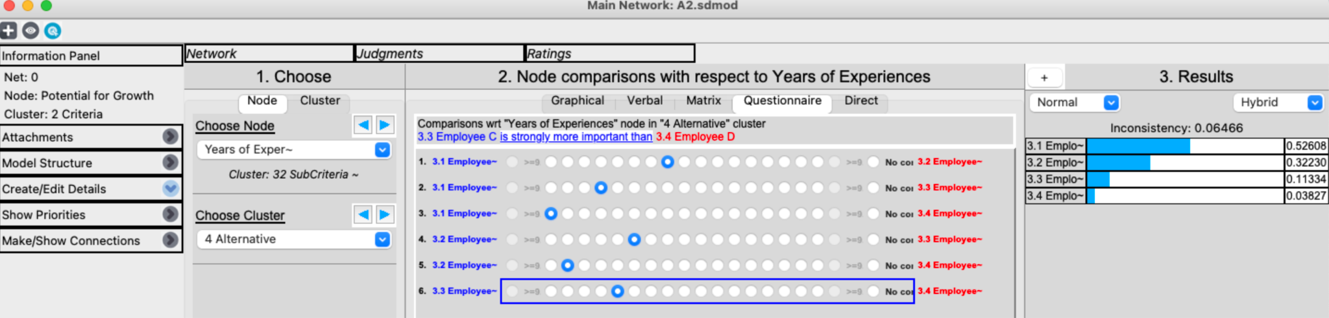

### Previous roles and responsibilities

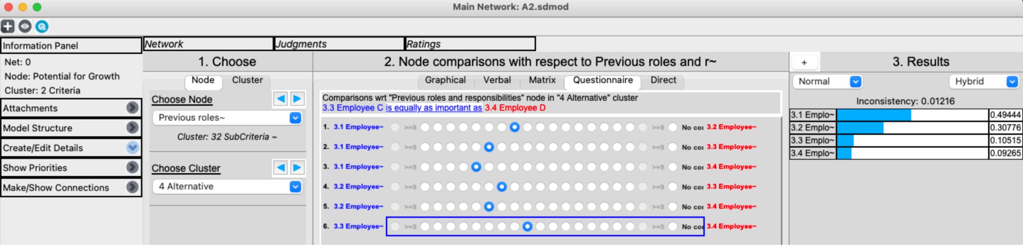

### Specialized skills

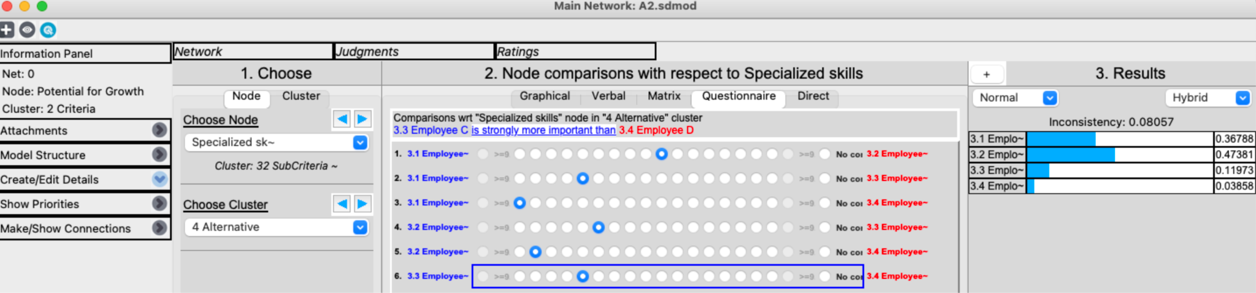

### Technical skills relevant to the job

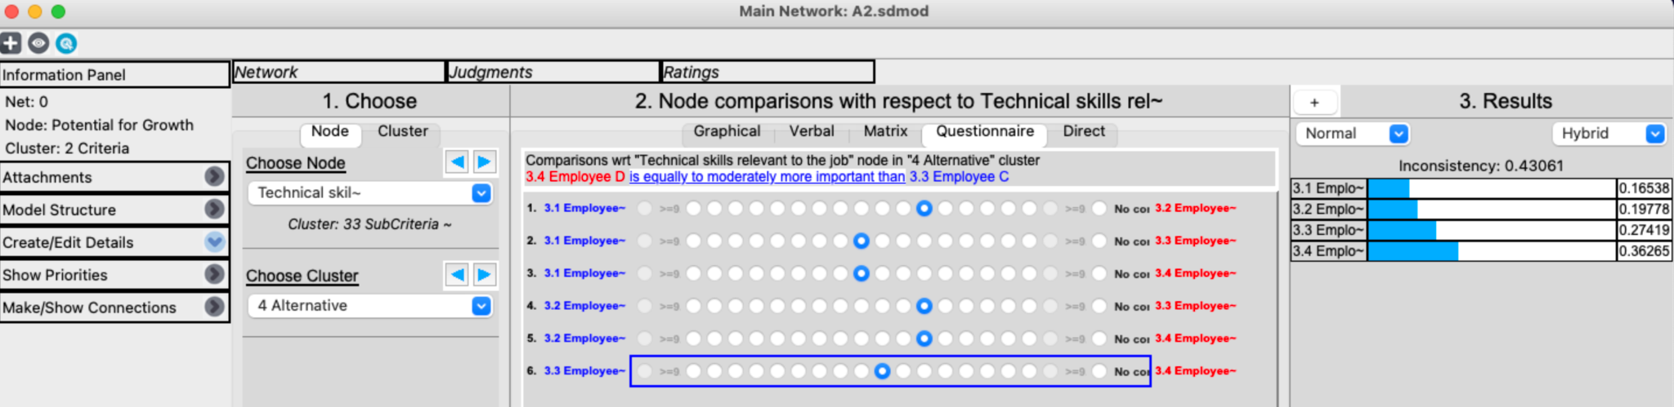

### Soft Skills

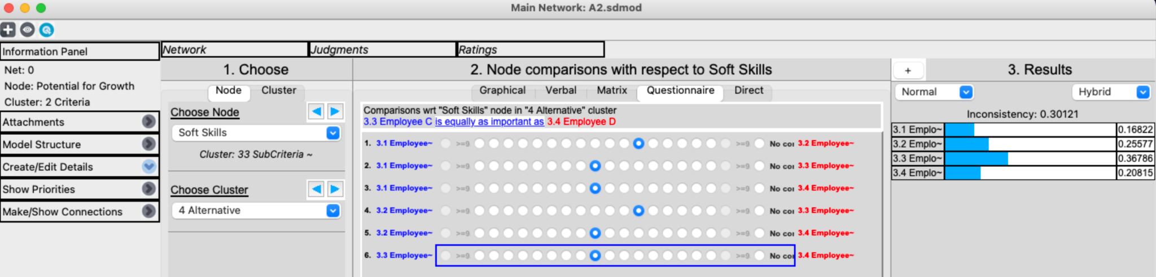

### Potential for growth

## Step 6: Perform Sensitivity Analysis

1. Goal with Experience and Tenure

When experience and tenure is 0.8, employee 1 would be the best choice to promote.

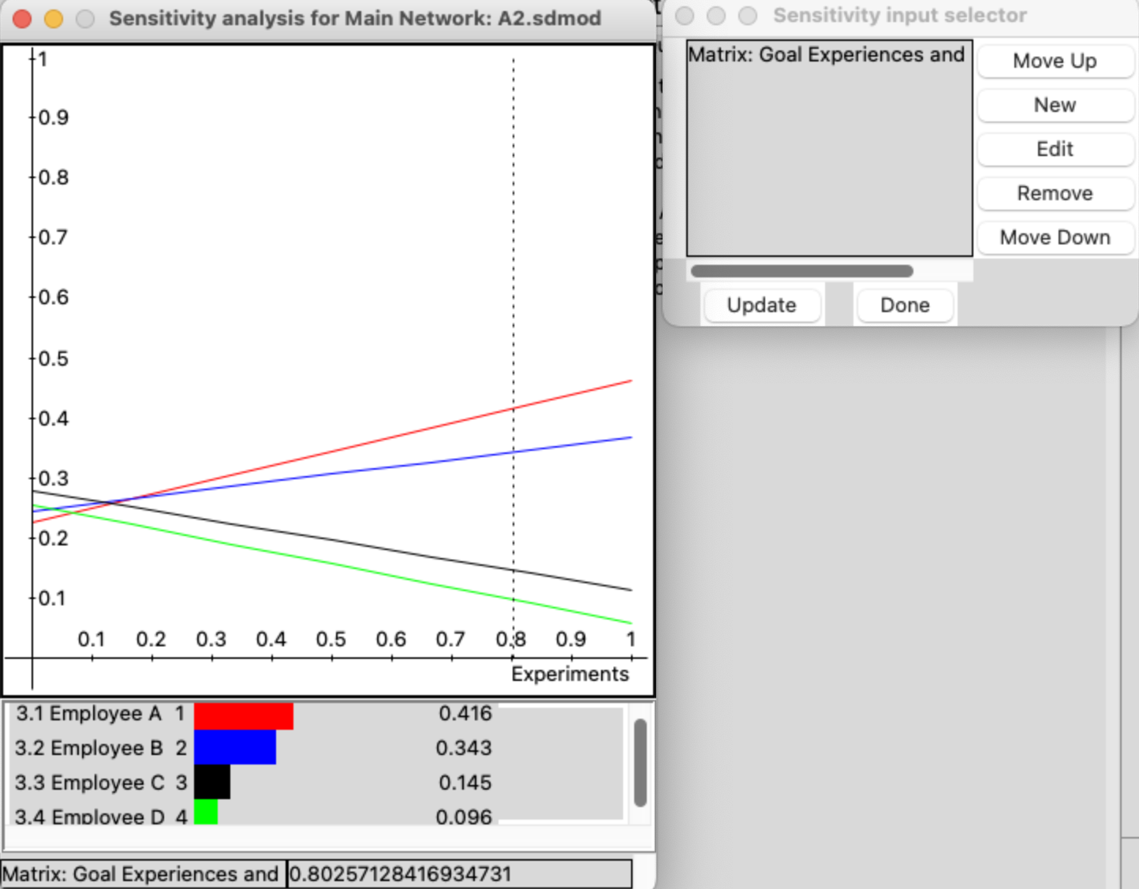

When experience and tenure is 0.5, employee 1 would be the best choice to promote.

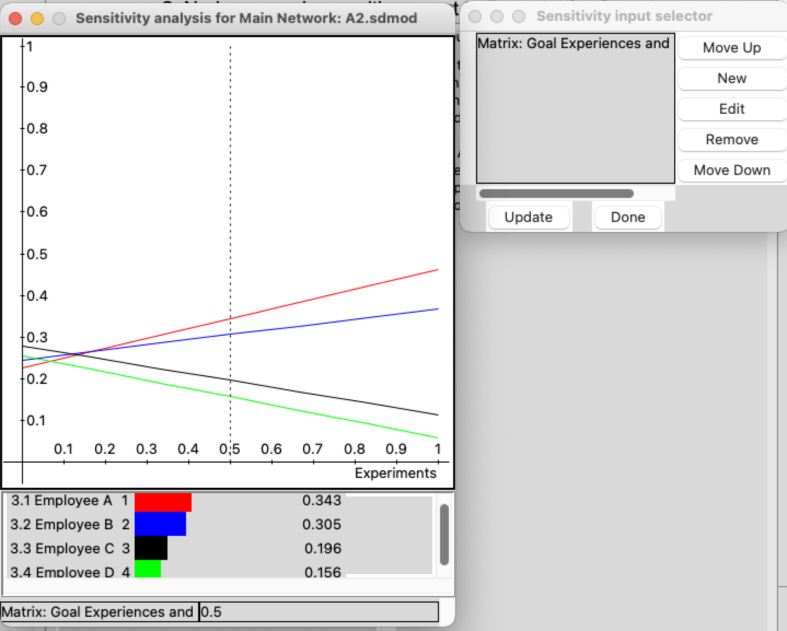

1. Goal with Performance

When performance is 0.5, employee 1 would be the best choice to promote.

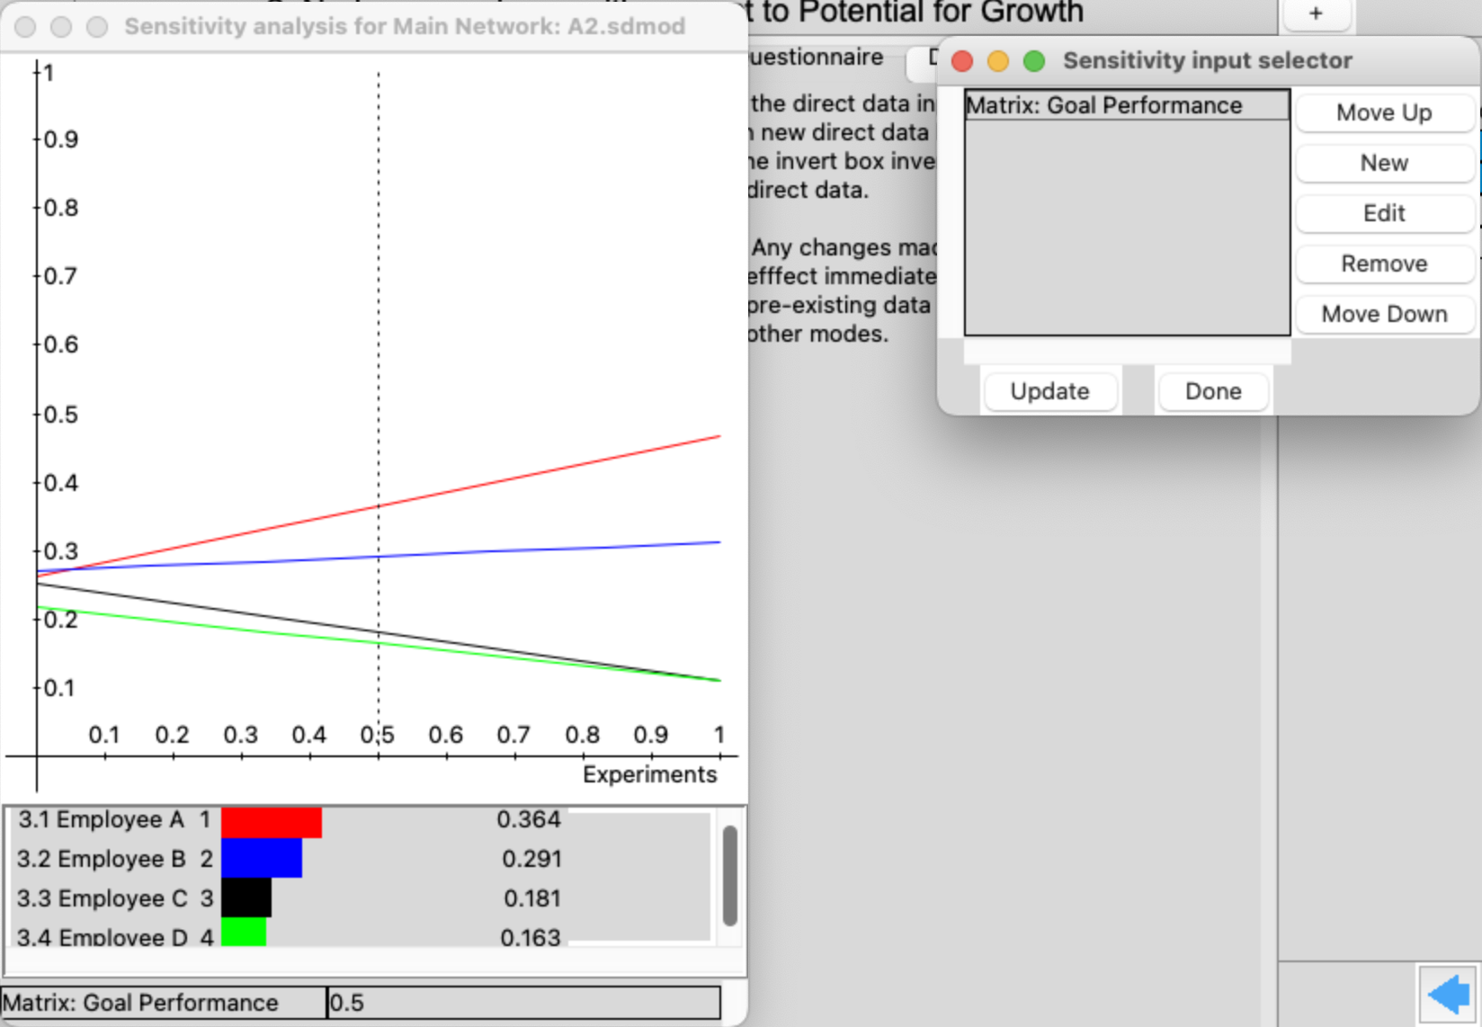

When performance is 0.8, employee 1 would be the best choice to promote.

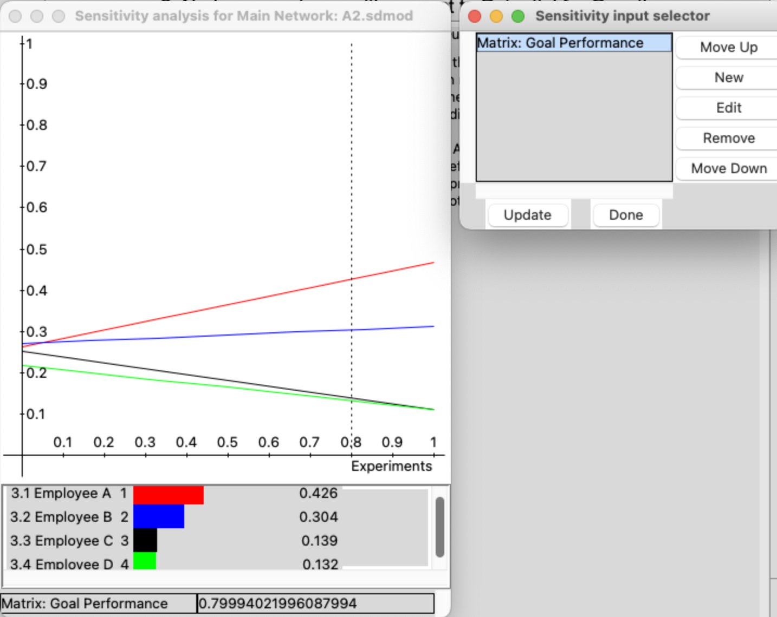

1. Goal with Potential for Growth

When potential for growth is 0.5, employee 1 would be the best choice to promote.

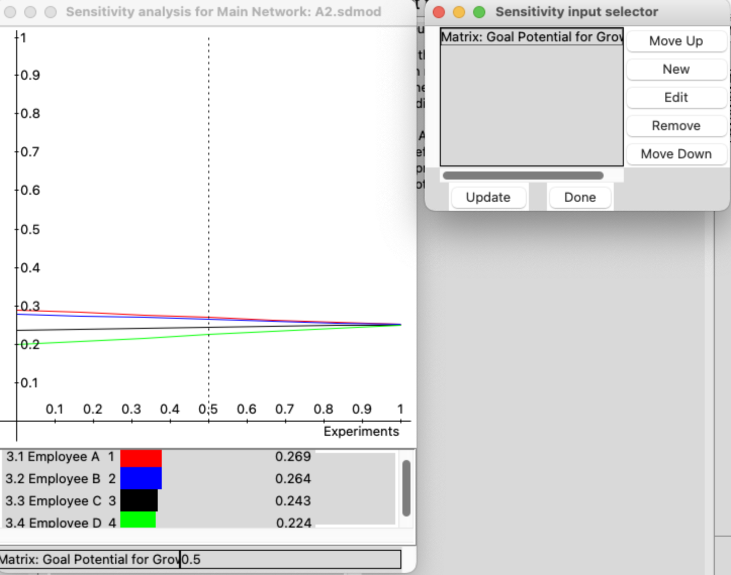

When potential for growth is 0.8, employee 1 would be the best choice to promote.

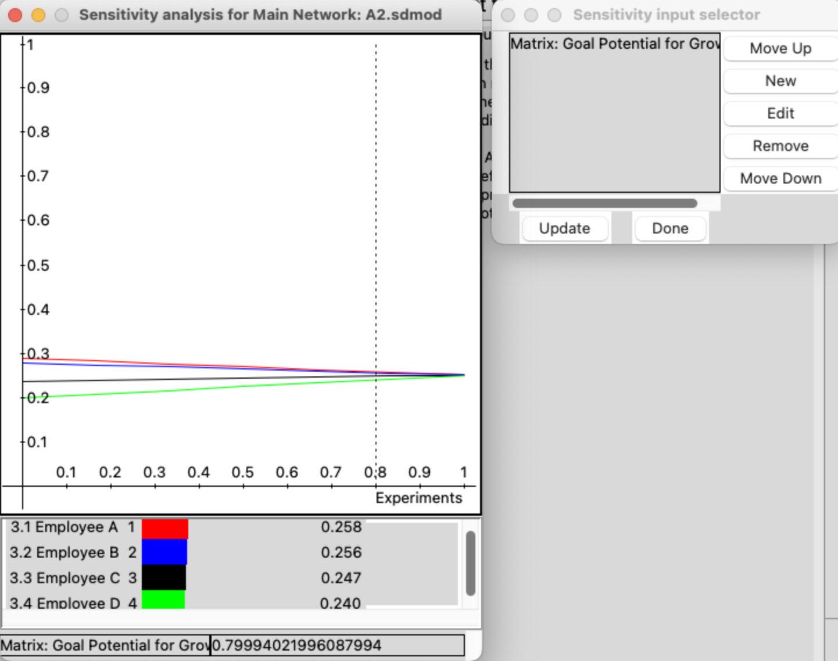

In this case, the results of employee 1 and 2 are not different. So, we can choose both.

1. Goal with Skills and Competencies

When skills and competencies is 0.5, employee 1 would be the best choice to promote.

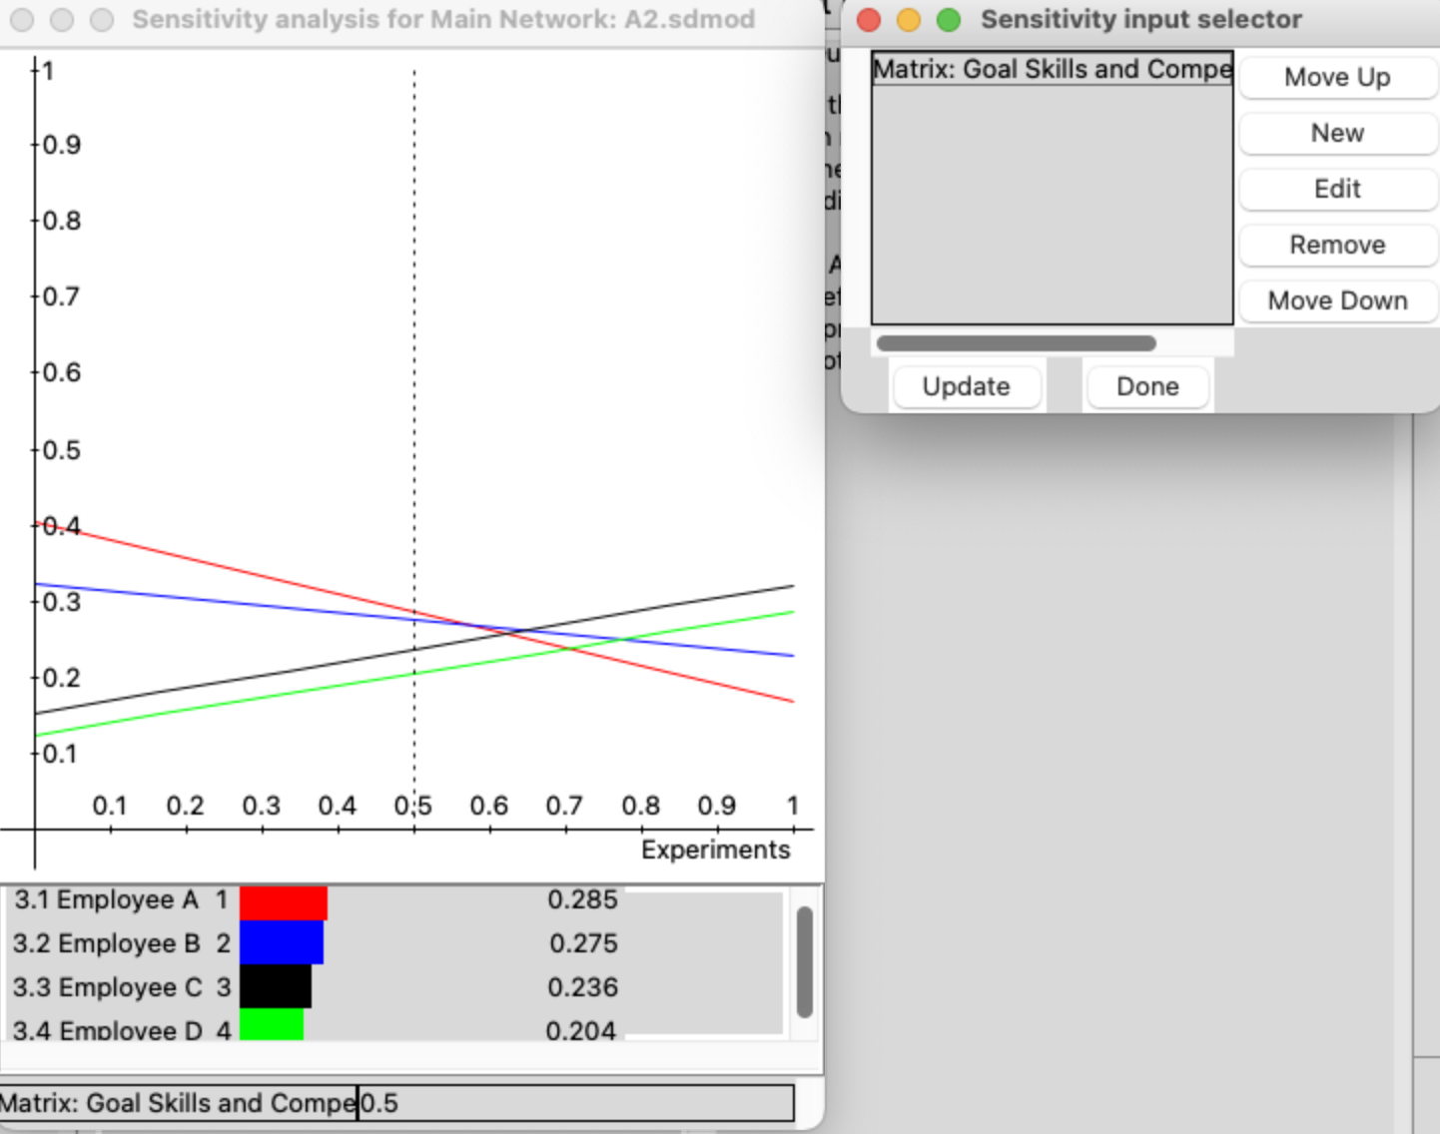

When skills and competencies is 0.8, employee 3 would be the best choice to promote.

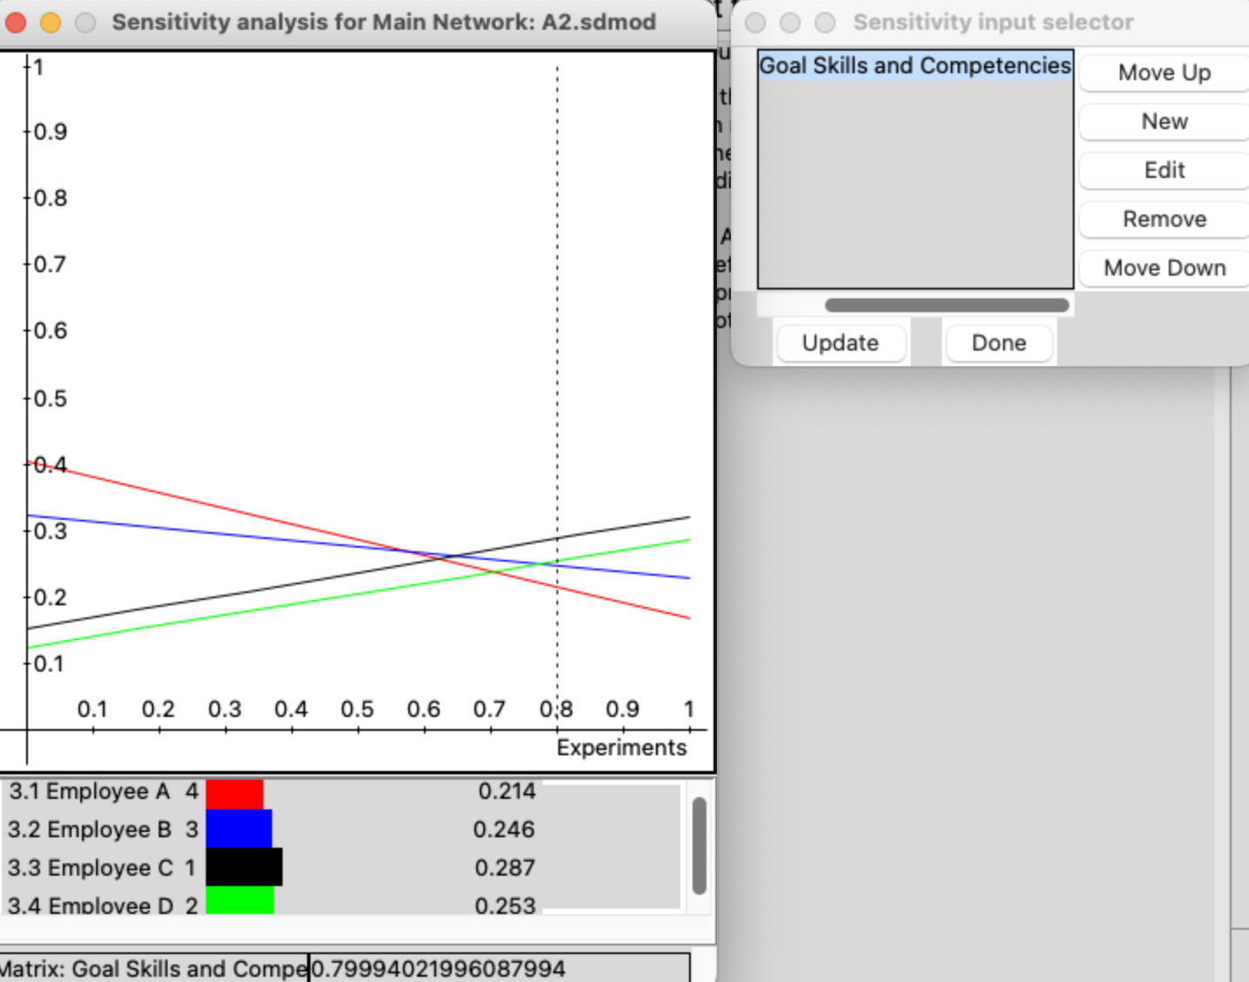

## Step 7: Report from Super Decision Software

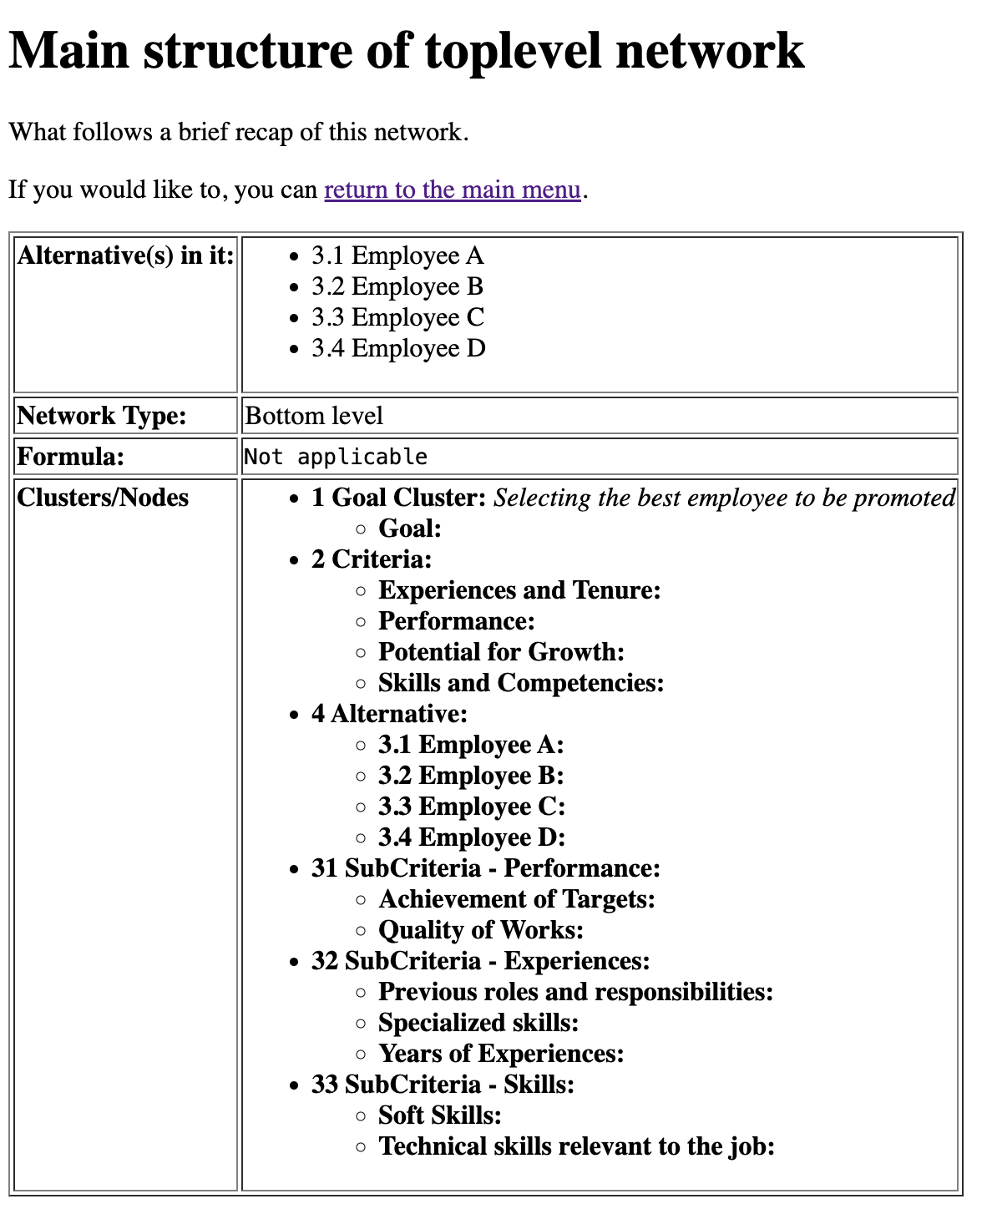

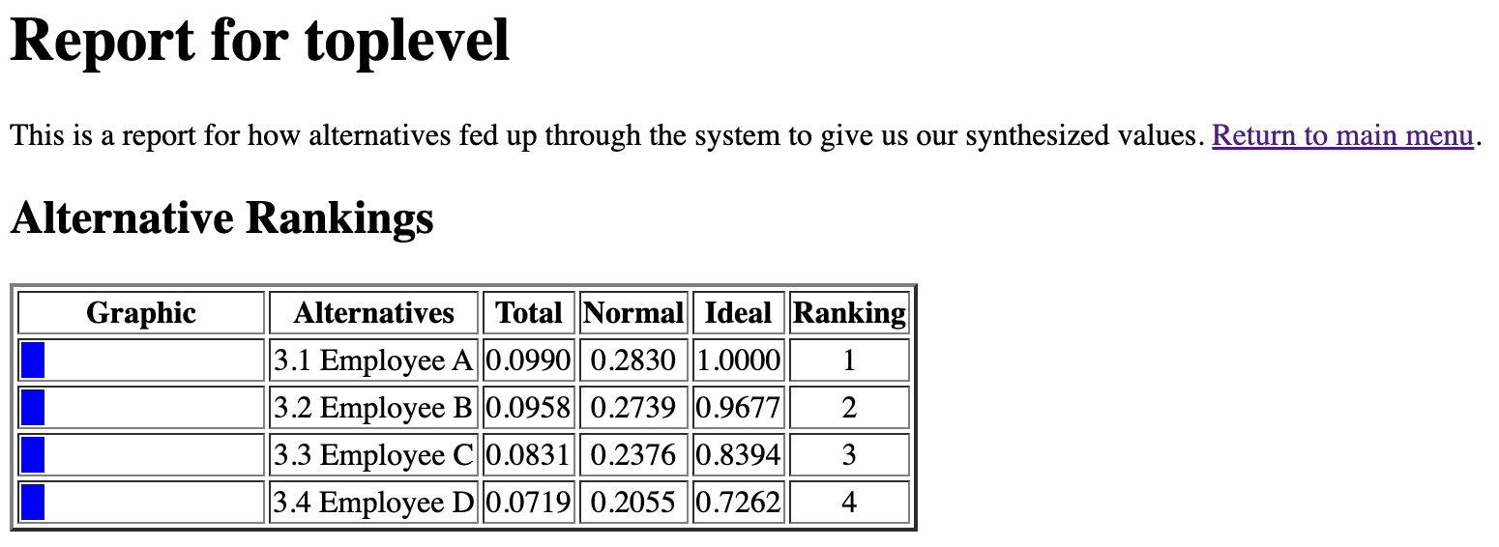

## Step 8: Final Decision

According to the report, I can choose employee 1 to be promoted.